Southampton International Airport
Health and Safety Training Charges
Effective from 1 January 2024
Southampton International Airport Limited (hereinafter “SIAL”)
Wide Lane
Southampton
Hampshire
SO18 2NL

Tel: 023 8062 7180
Fax: 023 8062 7294

Any queries relating to the payment of charges should be addressed to:
Finance Central Services
AGS Airports Limited
Erskine Court
St Andrews Drive
Glasgow
PA3 2SW

Tel: 0141 848 4872

Sundry Charges Payment Terms:

- These charges are exclusive of VAT
- A standard 14 days credit from the date of invoice applies to all charges included in this schedule.

Section Contents:

- Mandatory Health & Safety Training
- First Aid Training
- Fire Extinguisher Practical Training
- Fire Warden Training

- Manual Handling Training

- Cancellation

- Mandatory Health & Safety Training
Mandatory Health & Safety Training is provided in 3 areas / modules: Health, Safety and Environment, Fire Safety and Airside Safety. The charges for this training are:
Per delegate (£):
All 3 modules in a single session (“3 in 1”) £98
2 modules in a single session £85
1 module £48
Adhoc urgent session NEW £195.95

Airport Fire Service Training
- Train the Trainer
Train the Trainer Initial Session (Half Day) £1015.55
Price is per company attending up to a maximum of 4 delegates per company
There is no minimum number of delegates to run course.

For each delegate above 4, price per delegate per company £283.80

Train the Trainer: Annual Audit and Update in relation to the above £410
Charge is per company per visit to business partner premises.

- First Aid Training (a minimum of 4 delegates is required for any course date to proceed)
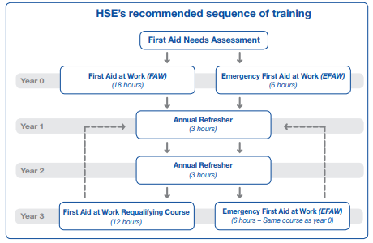

3 Day Course - First Aid at Work Certification (QA Level 3 Award in First Aid at Work (RQF) 2 units)
This 3 day course enables you to attain the knowledge and practical competencies to deal with a range of emergency situations.
Price per delegate £200

1 Day - EFAW - Emergency First Aid at Work (QA Level 3 Award in Emergency First Aid at Work (RQF) This 1 day course is for people who deal with emergency first aid at work enabling them to be workplace emergency first aiders.
Price per delegate £98

Annual Refresher - First Aid at Work Certification (QA Level 3 Award in First Aid at Work (Annual Refresher) (RQF) 1 units)
First Aid at Work Refresher course for individuals to maintain their skills in first aid at work.
Price per delegate £98

3 Hour – QA Level 2 award in CitizenAID (RQF)
CitizenAID enables the candidate to learn lifesaving skills and techniques in the event of a deliberate multiple casualty incident.
Price per delegate £65

Fire Extinguisher Practical Training (a minimum of 6 delegates is required for any course date to proceed):
This course trains delegates to use an extinguisher safely and effectively in the event of a fire and provides practical experience of tackling a fire including the use of an extinguisher on a live controlled fire. Delegates will also be instructed as to the different types of extinguishers and their methods of operation, capabilities and limitations.

Price per delegate £116.00

- Fire Warden Training

QA Level 2 Award in Fire Safety (RQF) (Fire Warden) £98
QA Level 1 Award in Fire Safety Awareness (RQF) £71.50

- Manual Handling Training

QA Level 2 Award in Principles of Manual Handling (RQF) £93.50
QA Level 1 Award in Safe Moving and Handling (RQF) £93.50

- Cancellation
Should cancellations reduce a course to below the minimum number of delegates stated, SIAL reserves the right to cancel the course at any time.
Charges for delegates not attending any session that they have been booked on:

Cancellation more than 14 days before course date: Full refund
Cancellation between 7 and 14 days before course date: 50% refund
Cancellation 7 days or less before course date or non-attendance: No refund (charges are payable in full)

A comprehensive range of commercial fire training such as First Aid, fire awareness in the work place, fire extinguisher training etc. can be specifically tailored to suit your company’s needs. To discuss individual training requirements and pricing, please contact Southampton Airport's Fire Service on 023 8062 7205.

